Setting up an Email Client
By
Joseph Tierney

Class: Computer Science 2

Tutor: Tony Bernes

To install an email server, first go to start, programs, administrative tools and then manage your server. Once it opens, click on Add or Remove a role. This will start the Configure Your Server Wizard. Click Next, and on the next window select Mail Server (POP3, SMTP) and click Next.

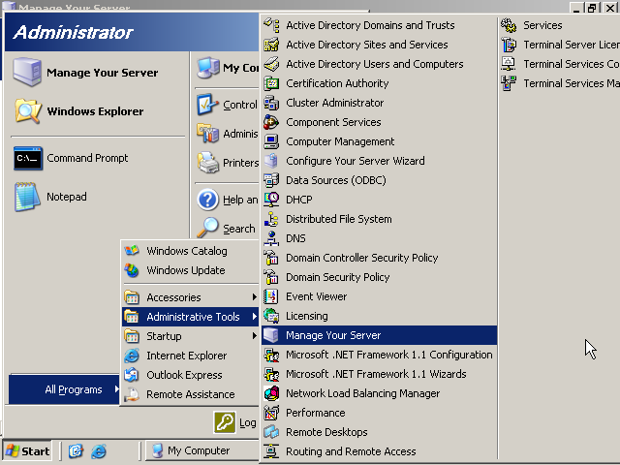
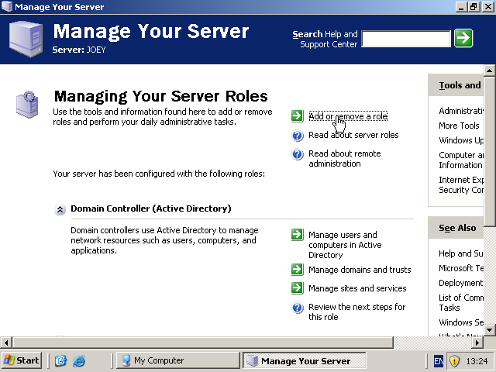

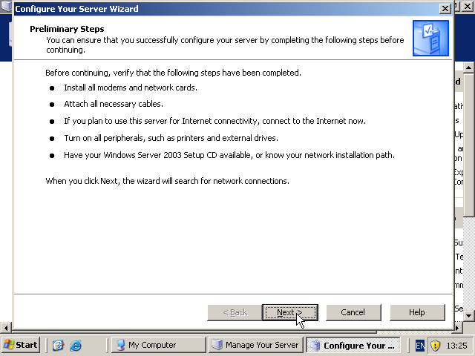

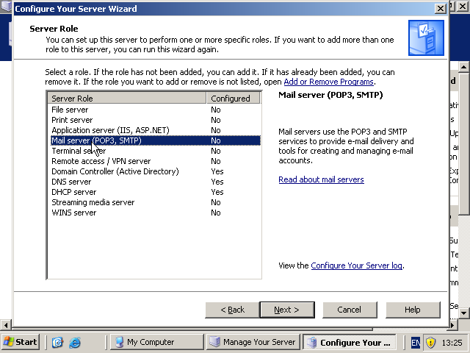

You will then be asked to select a type of user authentication and the name of the domain. Select Active Directory-Integrated.

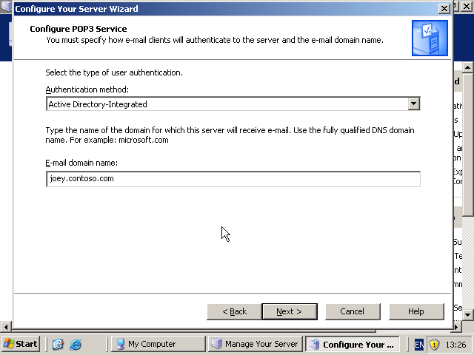
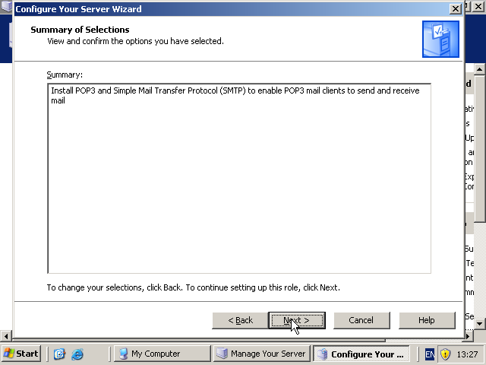

After the installation has been completed, This Server is Now a Mail Server windows should pop up. Click Finish.
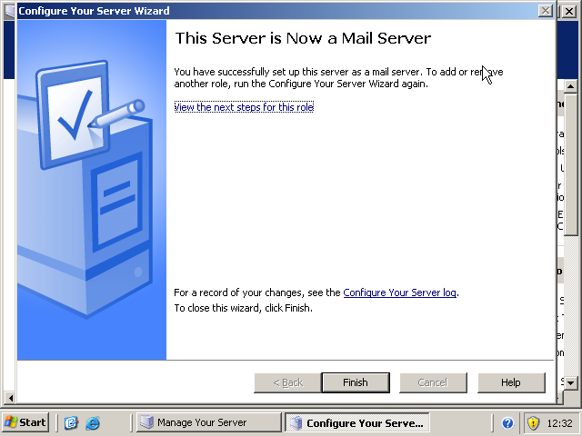
To configure the email server, click start, and in run type “server.msc” and click on result which will open up the POP3 Service. Click on the computer name, in this case, Joey, in the left pane and click on Server Properties in the right.

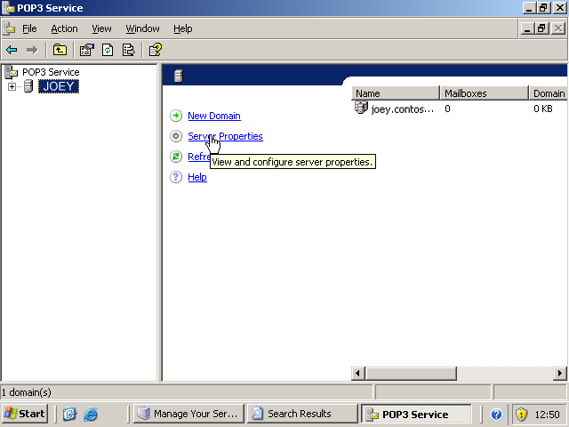
Clicking on this will bring up the properties for the mail server.

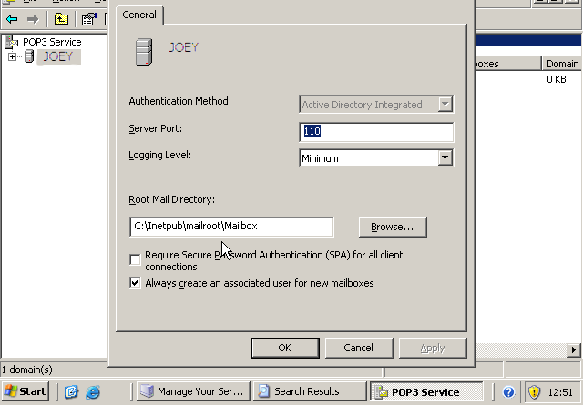

To create a mailbox, click on the domain in the left hand pane and then click on the Add Mailbox in the right hand pane.

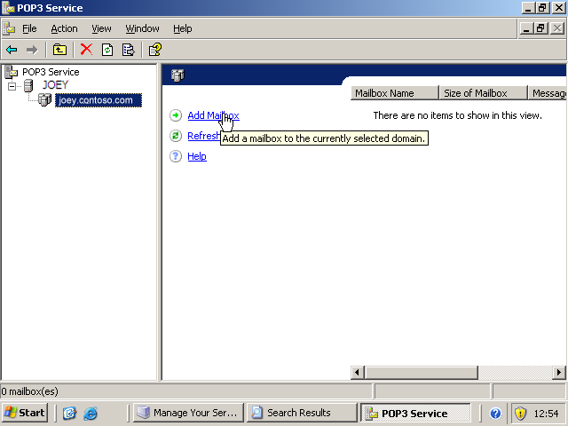

This will open up the Add Mailbox window where you need to enter a name and a password, click ok when done.

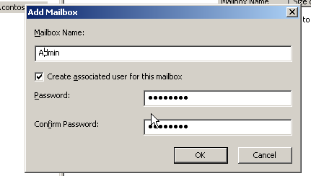
Read the pop-up box that will tell you how to configure email clients and click ok. This will create a mailbox and user named Admin.

To configure the SMTP, open Computer Management. Expand Services and Applications and then expand Internet Information Service. Right click Default SMTP Virtual Server and then click on Properties.
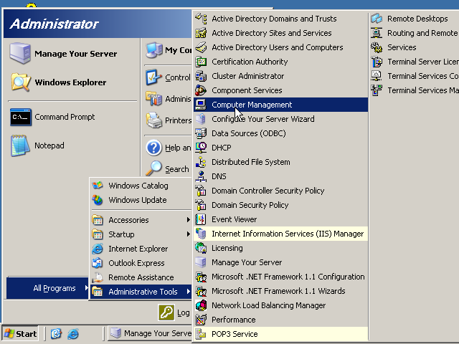
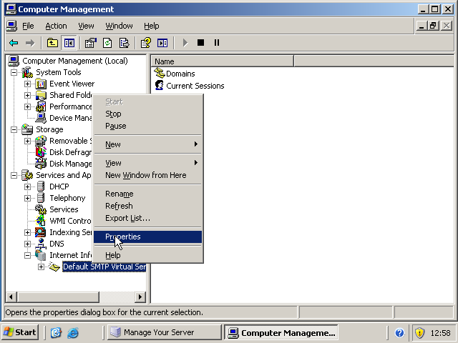

Once the properties tab is open, Click the Access tab and then Click the Authentication button.
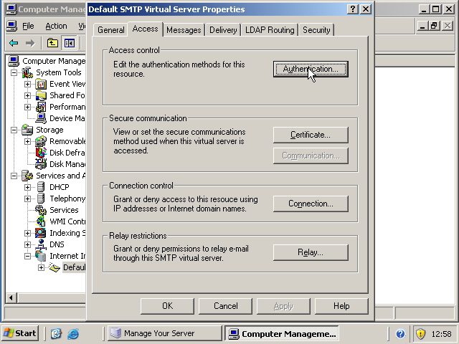

When the next screen pops up, tick Anonymous access and Integrated WindowsAuthentication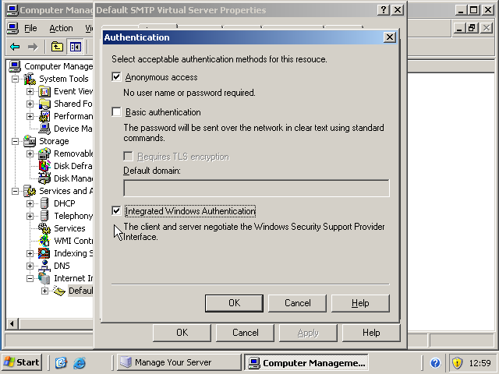
From the Properties window, click the Relay button. Check that Allow all computers which successfully authenticate to relay, regardless of the list above is ticked.
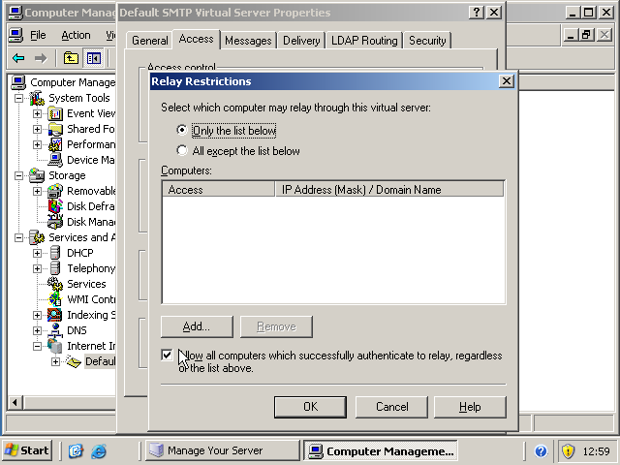

To configure the network to make sure it is as secure as possible, we need to enable SPA. This will send the user name and password from the client encrypted.

To do this, click Start, Run, type in p3server.msc. In the right pane, right click the computer’s name and click Properties. Check that the box Require Secure Password Authentication is clicked and click OK.
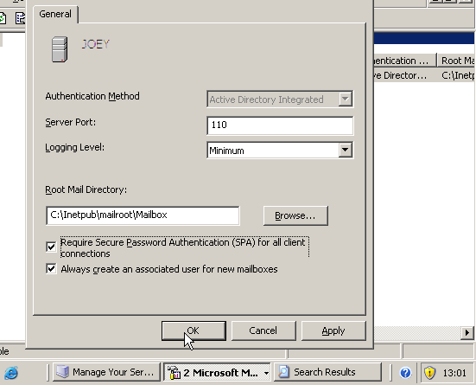

Restart Microsoft POP3 afterwards.

